AIM: TO PERFORM GCD OF TWO NUMBERS USING TWO NUMBERS BY 8085 PROCESSSOR.

PROGRAM:

LXI H,8000H

MOV A, M

INX H

MOV B, M

LOOP: CMP B

JZ STORE

JC EXG

SUB B

JMP LOOP

EXG: MOV C,B

MOV B, A

MOV A, C

JMP LOOP

STORE: STA 8050H

HLT

INPUT:

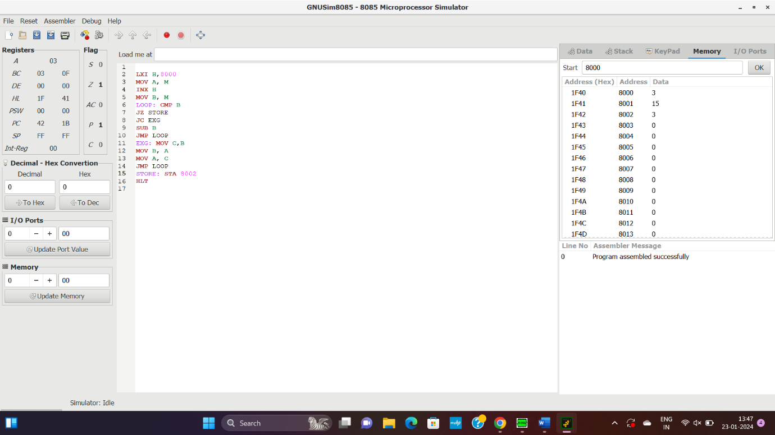

OPUTPUT:



RESULT: THUS THE PRIOGRAM WAS EXECUTED SUCESSSFULLY USING 8085 PROCEESOR